**Connecting to the Temple Linux Server**

*A Simple Guide*

Hello CIS2107 students! Here is a brief guide to get you up and running on Temple’s Ubuntu (Linux Server). You are required to use Temple’s Linux server for development throughout this course. Gaining Linux experience (and experience using a shell program) will be a very valuable skill for you in Operating Systems and your career in computer science in general. If not for development, you should definitely use the Linux server to test your code, since it is the OS I will be compiling and running all of your submitted source code on throughout the semester.

**Resources You Will Need**

**-Any SSH Client**

* On Mac, you already have ssh on terminal. Simply, open terminal and type SSH YourUserName@cis-linux2.temple.edu
* (PuTTY is **HIGHLY** recommended)

-Link to PuTTY Download (make sure you pay attention to the instructions on the page, and which version you are downloading. <https://www.chiark.greenend.org.uk/~sgtatham/putty/latest.html>

**-Any FTP Client**

* Use WinSCP for Windows (recommended for Windows)
* You can use FileZilla for both Windows and Mac

**Resources You May Be Interested In**

**-**Link to the SSH Wiki: <https://en.wikipedia.org/wiki/Secure_Shell>

**-**Brief article explaining some cool things you can do with SSH:

<https://www.howtogeek.com/114812/5-cool-things-you-can-do-with-an-ssh-server/>

-Short video explanation of the technical side of SSH and some of its features: <https://www.youtube.com/watch?v=ORcvSkgdA58>

-Brief article explaining some technical details of FTP: <https://www.deskshare.com/resources/articles/ftp-how-to.aspx>

**Guide**

**Step 1:** Download and install both of the programs you are going to need (see the **Resources You Will Need** section above).

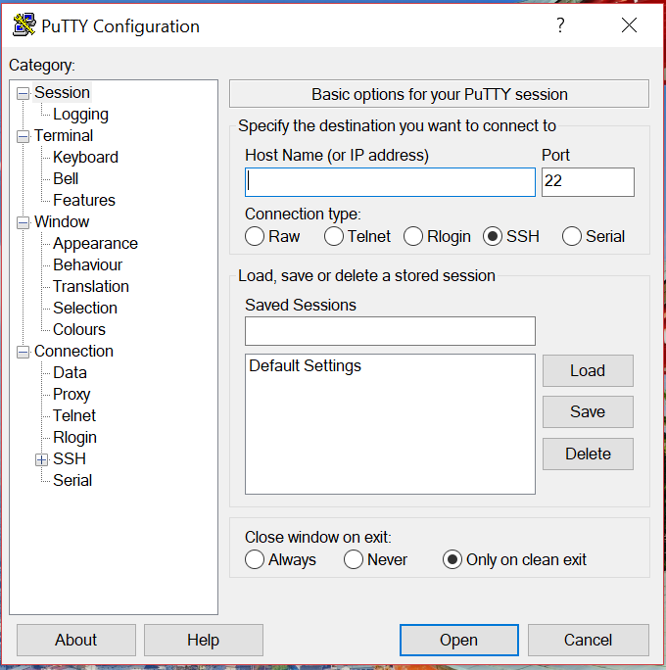

**Step 2:** Open up PuTTY.exe. PuTTY is your SSH client, a program that will help you remotely connect to some other machine over the internet.

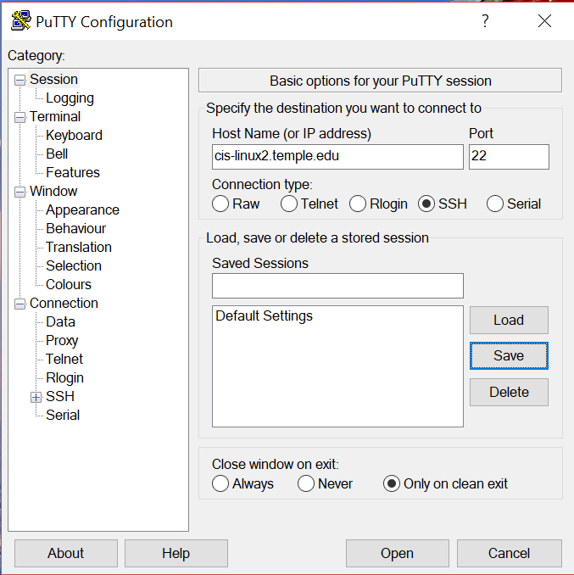

**Step 3:** Type “*cis-linux2.temple.edu”* into the **Host Name** field. Leave the **Port** field at 22. Make sure the **Connection type** option is checked.

**Step 4:** You may be bothered by some warning messages about secure connections; just select “Yes” for any of those. You will definitely be bothered for login credentials (username and password). Enter your Accessnet information for these.

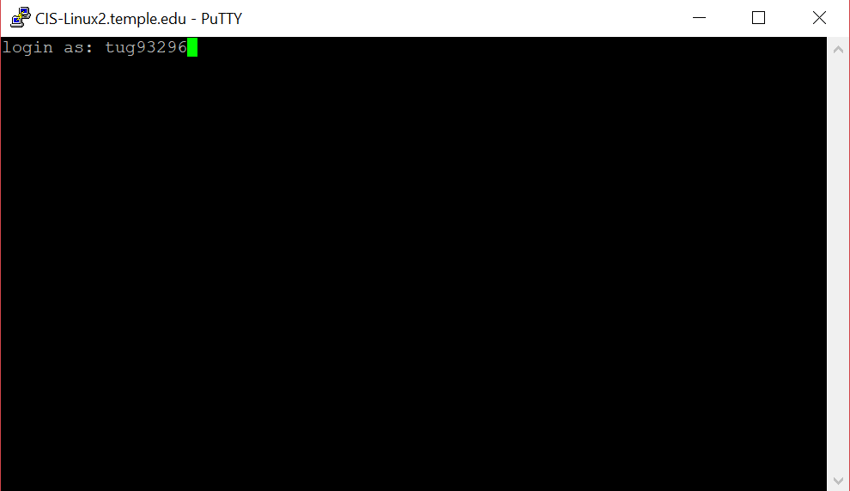

**Step 5:** Once you see the screen pictured below you are in!

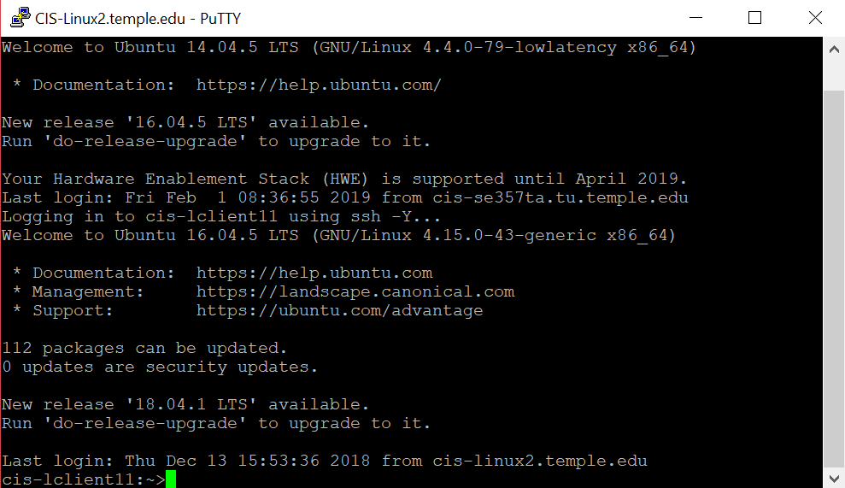

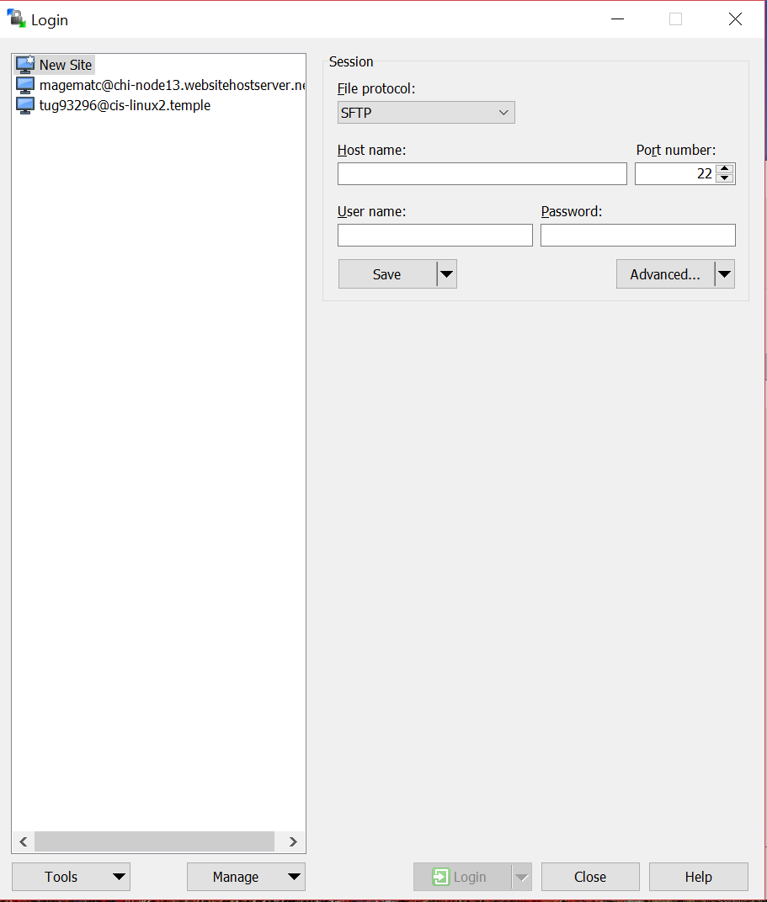

**Step 6:** The process for connecting to the server with your chosen FTP client is very similar. The screenshots below are taken from WinSCP, but they should be similar for any client you use. Open up your FTP client.

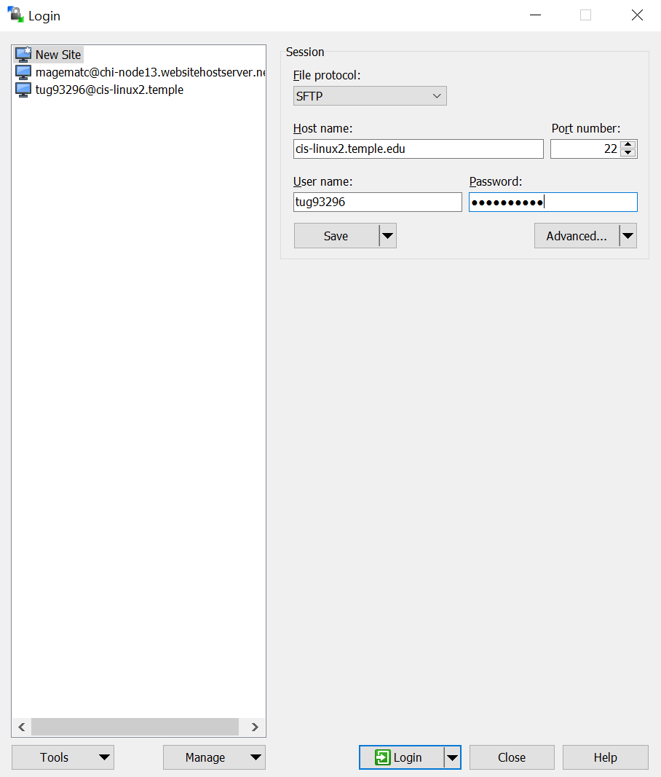

**Step 7:** Once again enter *“cis-linux2.temple.edu”* for the **Host Name**, and once again use your Accessnet for the **User name** and **Password** fields.

**Step 8:** You may be bothered about secure connections once again, but just select “Yes” for any prompts, and then you are connected! The left-hand side is you local machine, while the right-hand side is the remote Linux server. Simply drag-and-drop between both windows to upload/download to/from the server!

And that is all there is to it! Please reach out if you have any more questions.